

# **526 Original Claims**

**What Is It?**

**526 Disability Claims – Original Claims Application release will include the following features:**

- File for an original disability claim (previously unavailable on va.gov)

*Target launch date for 526:*

**Table of Contents**

**526** **v2** 1

**User Access**3

Who can access these tools? 3

How can users access these tools? 3

**Navigation**4

**Functionality**6

**Error & Notification Log**32

# User Access

## Who can access these tools?

Veterans who are signed in with the highest level of identity verification on VA.gov (LOA3), and are found in the Master Veteran Index (MVI).

## How can users access these tools?

Users can sign in using their DS Logon Premium, MHV Premium, or ID.me accounts. They need to be registered as LOA3 users and found in MVI.

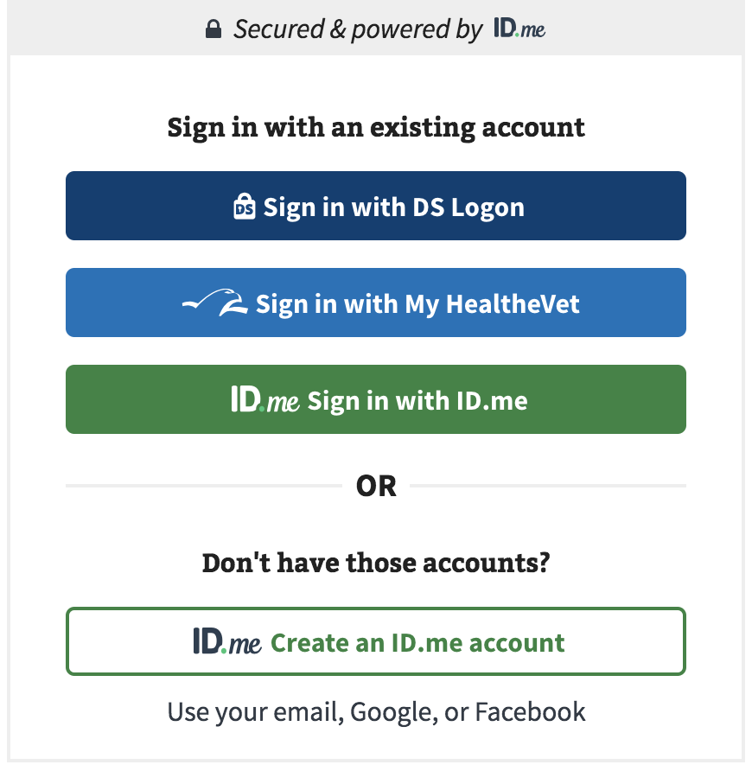

# Navigation

**Direct url:** https://VA.gov/disability-benefits/apply/form-526-all-claims/

or

The link for the disability claims application can be found on the **VA.gov** homepage.

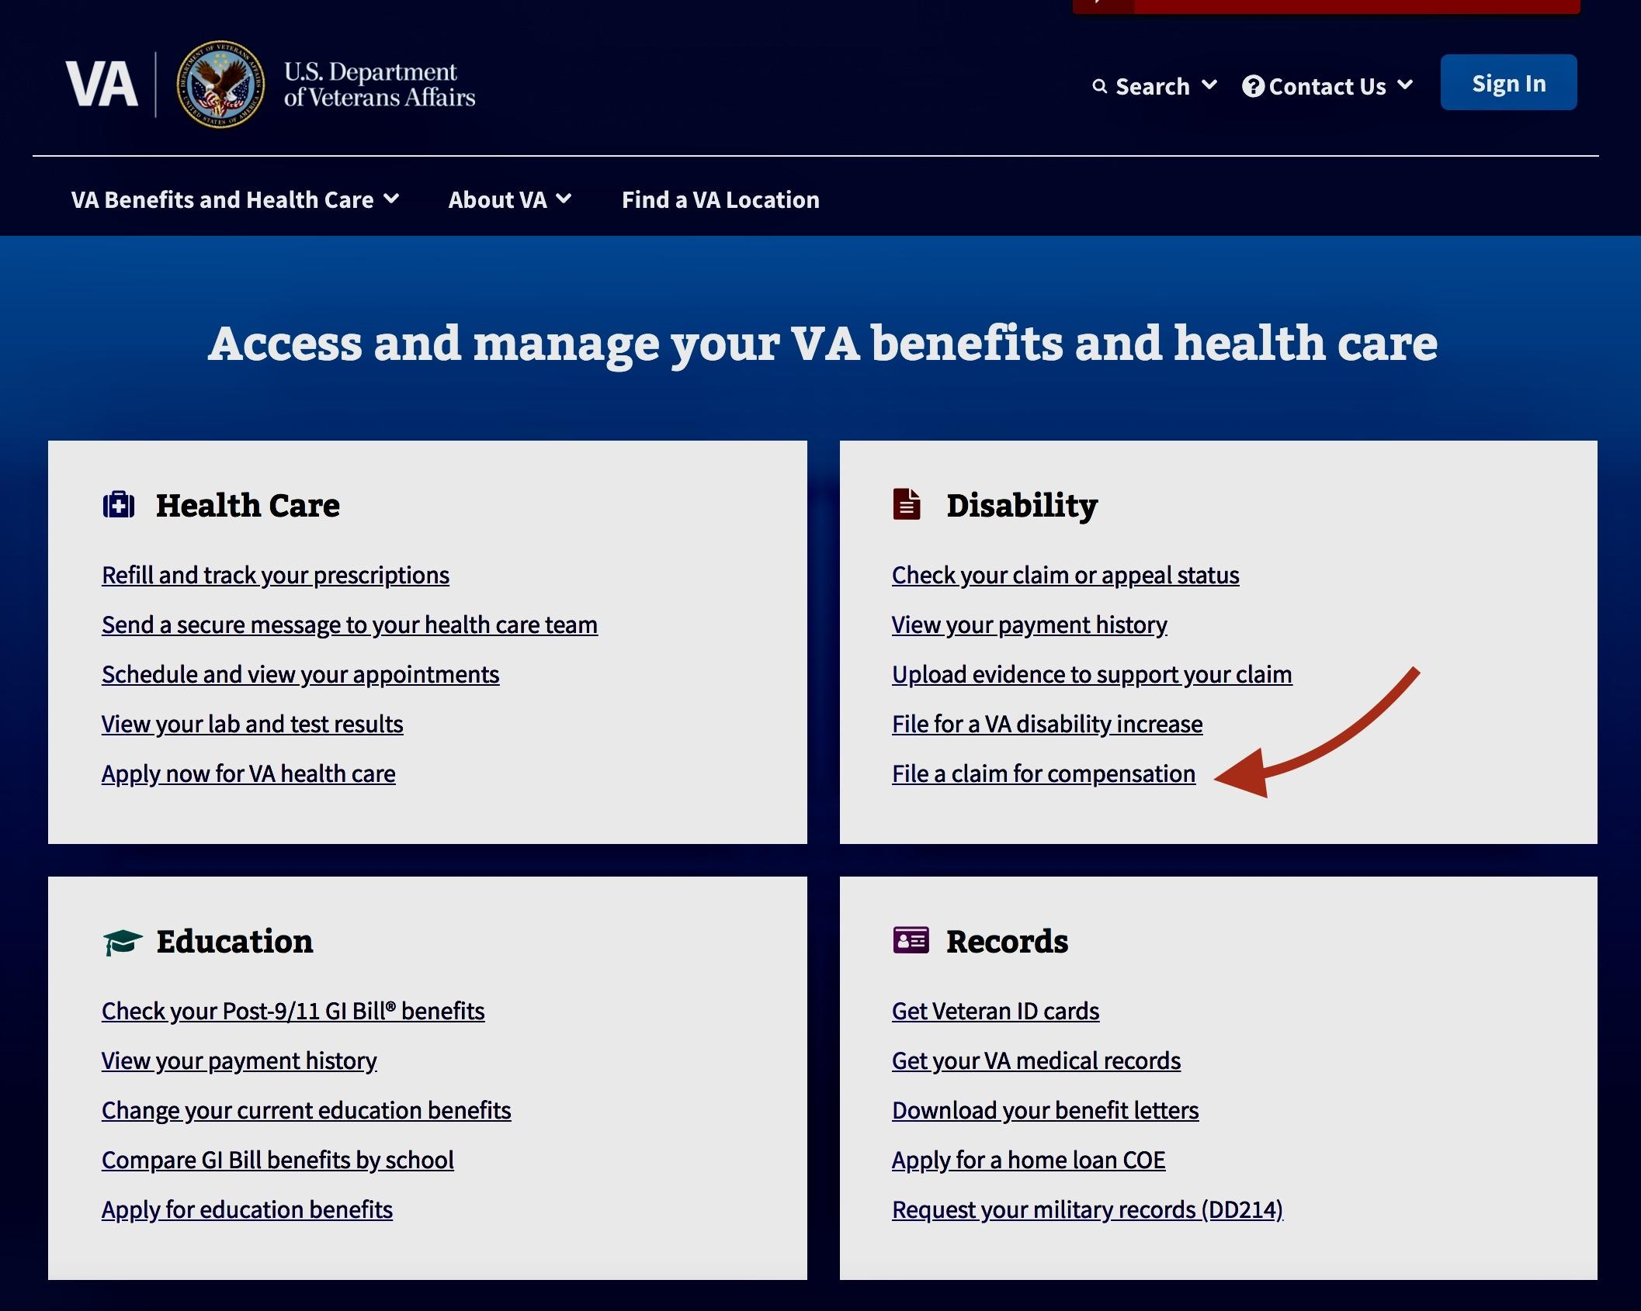

# Claims Wizard

https://www.va.gov/disability/how-to-file-claim/

Veterans can file an original claim or for a new or secondary disability, or for a condition that has gotten worse can use the disability claim tool. Servicemembers who are less than 90 days from separation can file a claim on eBenefits (though at the time of this writing we are working on getting that to va.gov as well).

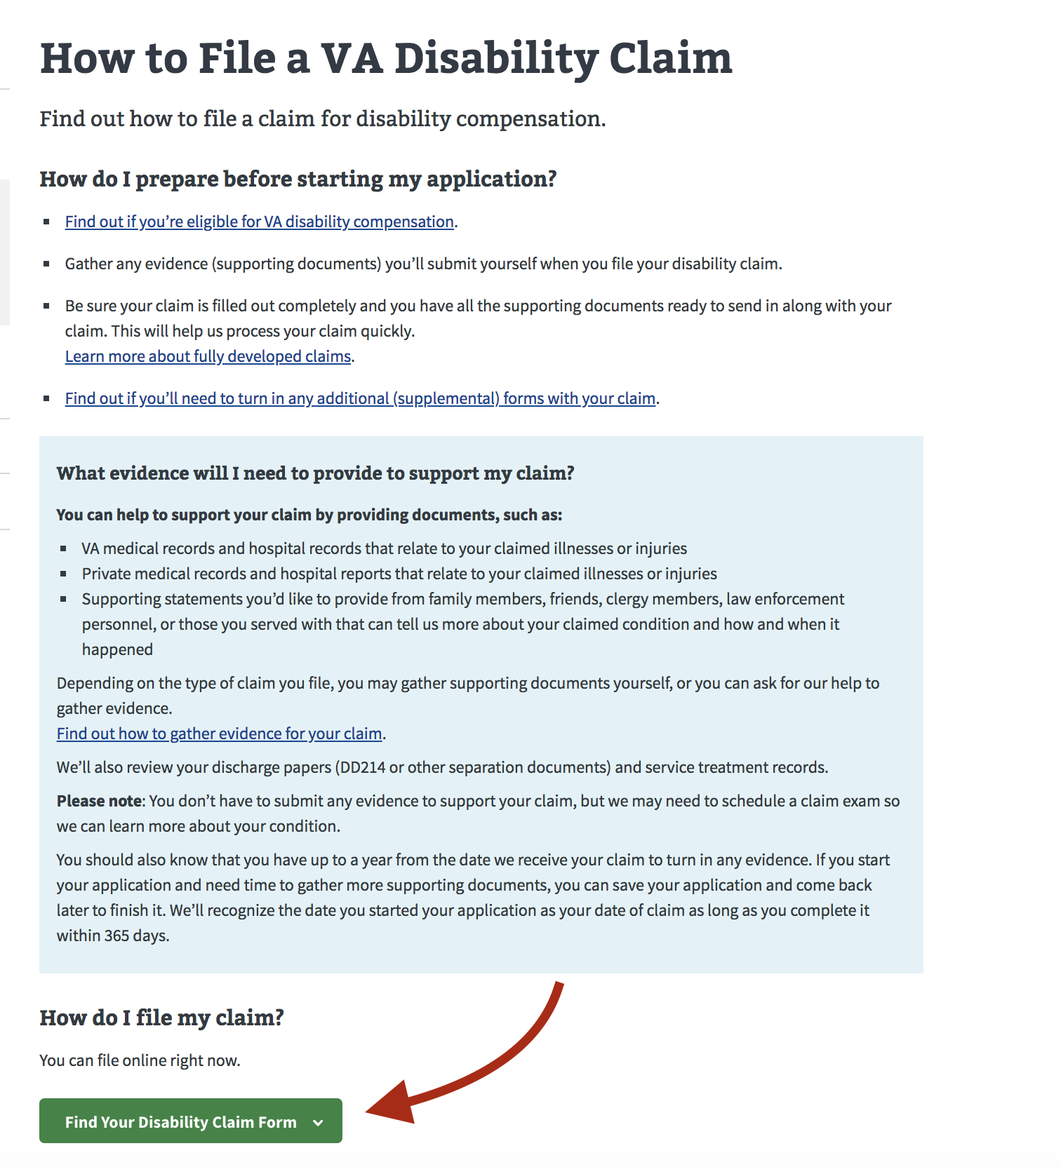

# Functionality

<https://staging.vets.gov/disability-benefits/apply/form-526-disability-claim/veteran-information>

**Part 1: Veteran Identity**

On this screen the Veteran will review their identity and military information to check for accuracy and make corrections as needed.

**Name, DOB, Gender** - view only

**Service History** - editable

**New Condition or Existing**

User must select at least one option:

**Alternative name(s)**

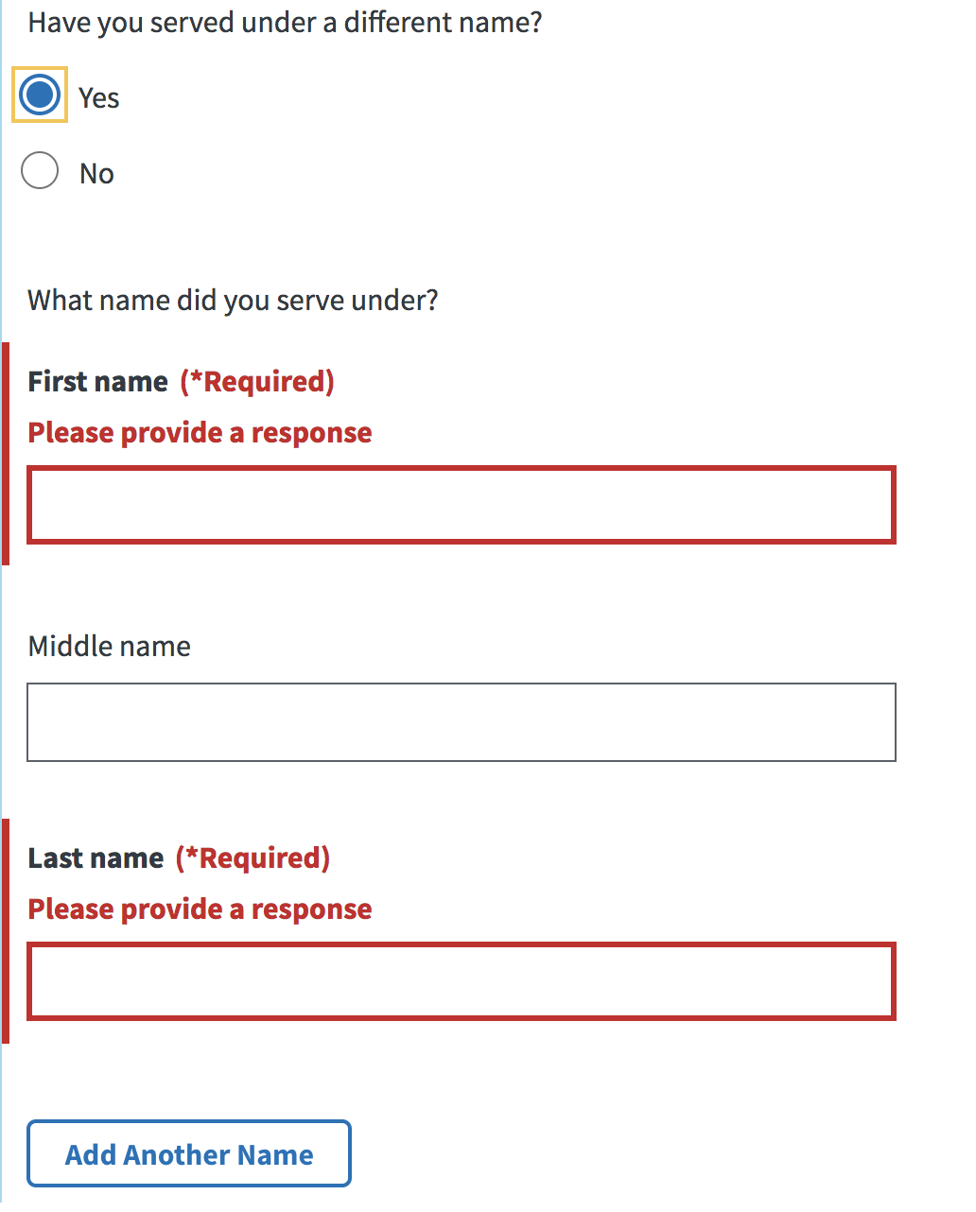

**Service History**

* Branch of Service: required
* Service start date: required
* Service end date: required

**Combat Zone**

Did you serve in a combat zone after September 11, 2001? - required

**Part 2: Disabilities**

**Rated Disabilities**

The Rated Disabilities screen displays a Veteran’s rated service-connected disabilities. They can choose the condition that they’re filing for an increase because the condition has gotten worse.

**New Disabilities**

The New Disabilities screen asks a Veteran to describe or provide information about their new disabilities. (Short answers are better here. A Veteran will have an opportunity to provide more details on the following screen.)

Veterans will be asked how their disability is related to their service.

A Summary of Disabilities screen will show new and rated conditions the Veterans is claiming.

If the Veteran is a Prisoner of War, they’ll be asked if any of their new conditions is related to their POW experience.

**Ancillary Wizard**

The Ancillary Forms Wizard asks the Veteran questions about their situation to to determine if they’re eligible for additional disability benefits. Based on the Veteran’s answers, the wizard will suggest supplemental forms a Veteran can file with their disability claim. (For example, Aid and Attendance benefits, Adaptive Housing benefits, Automobile Allowance, Individual Unemployability.)

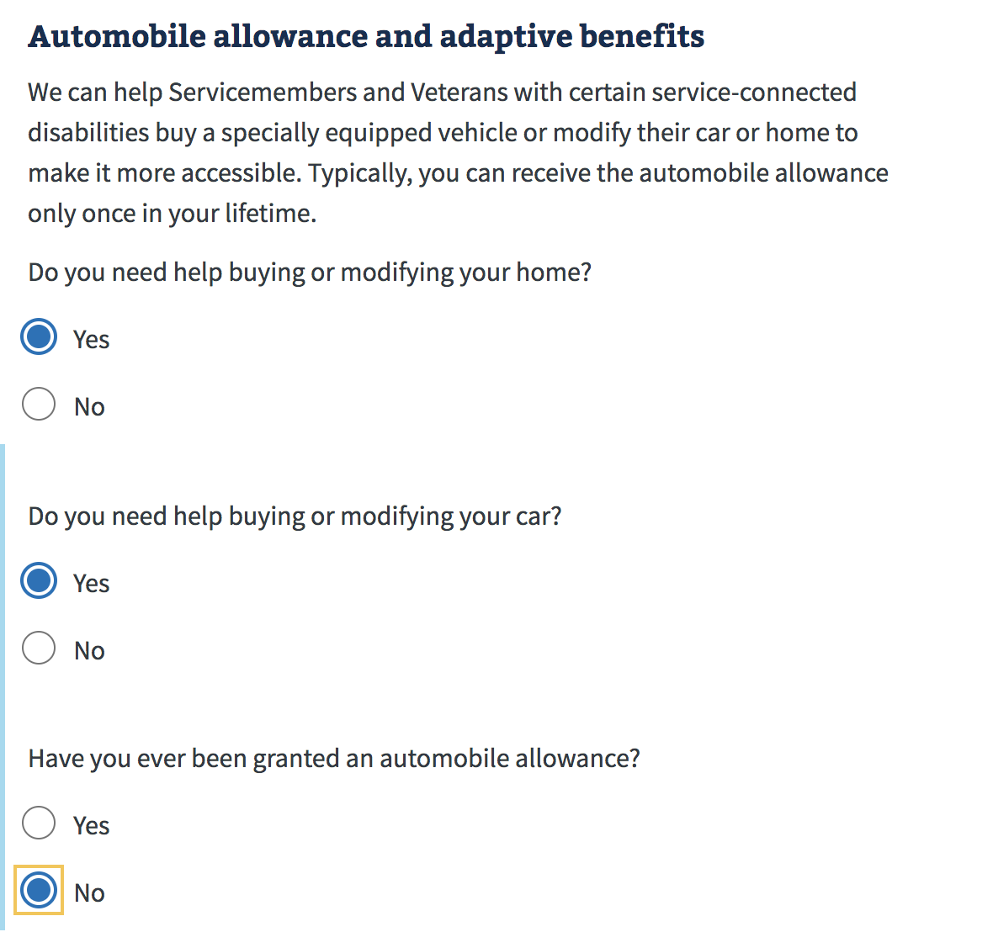

The suggested forms are summarized in a screen for download.

**Part 3: Evidence**

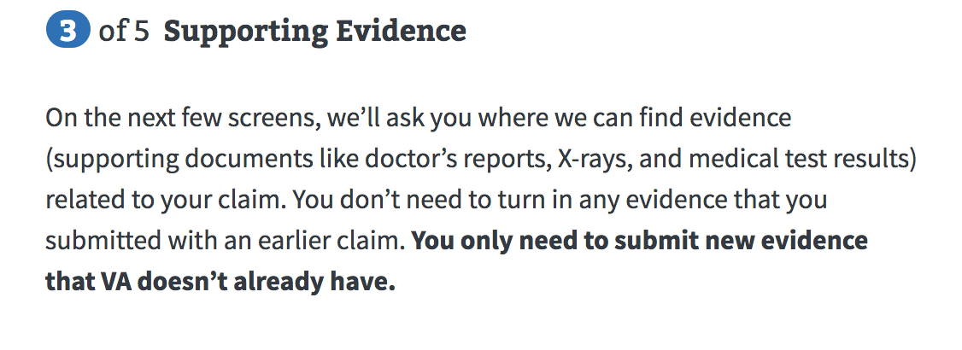

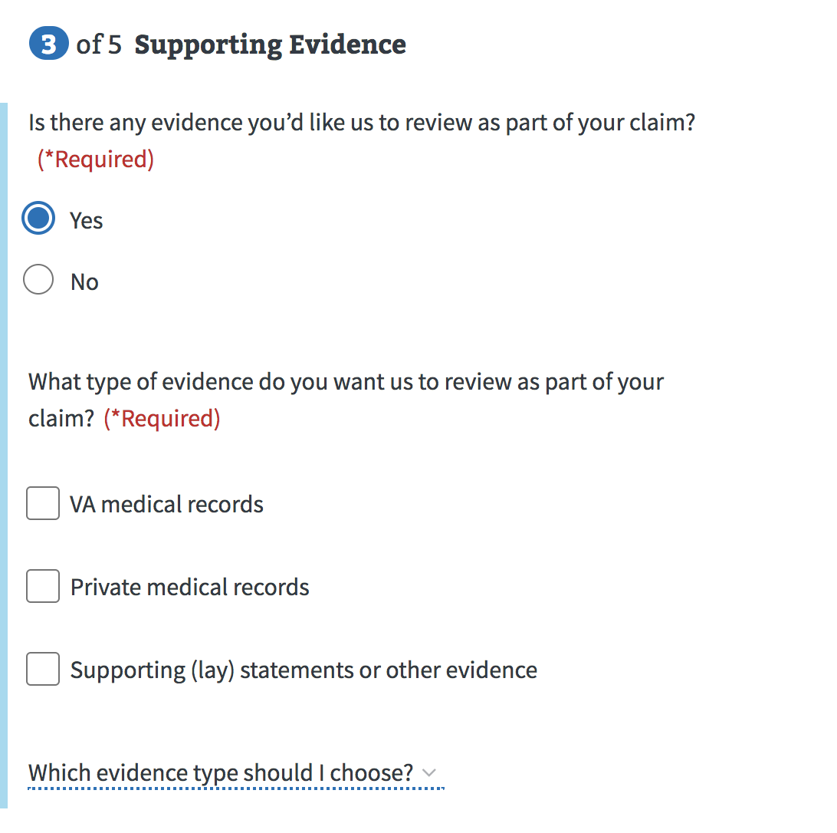

**VA Medical Records**

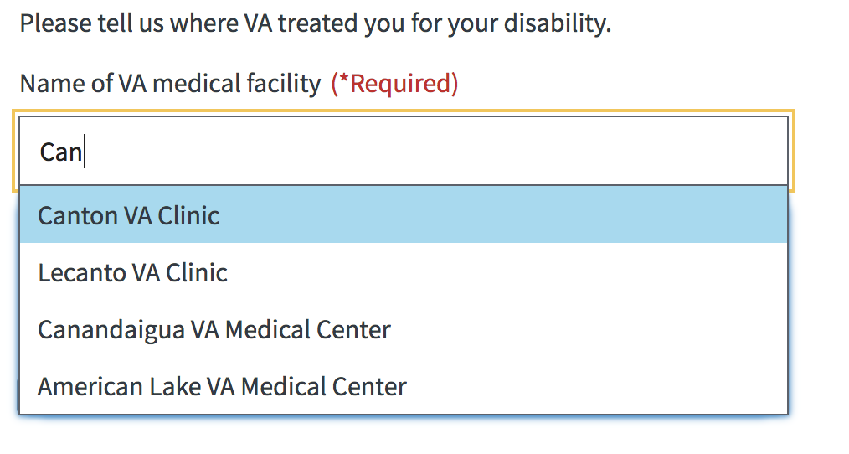

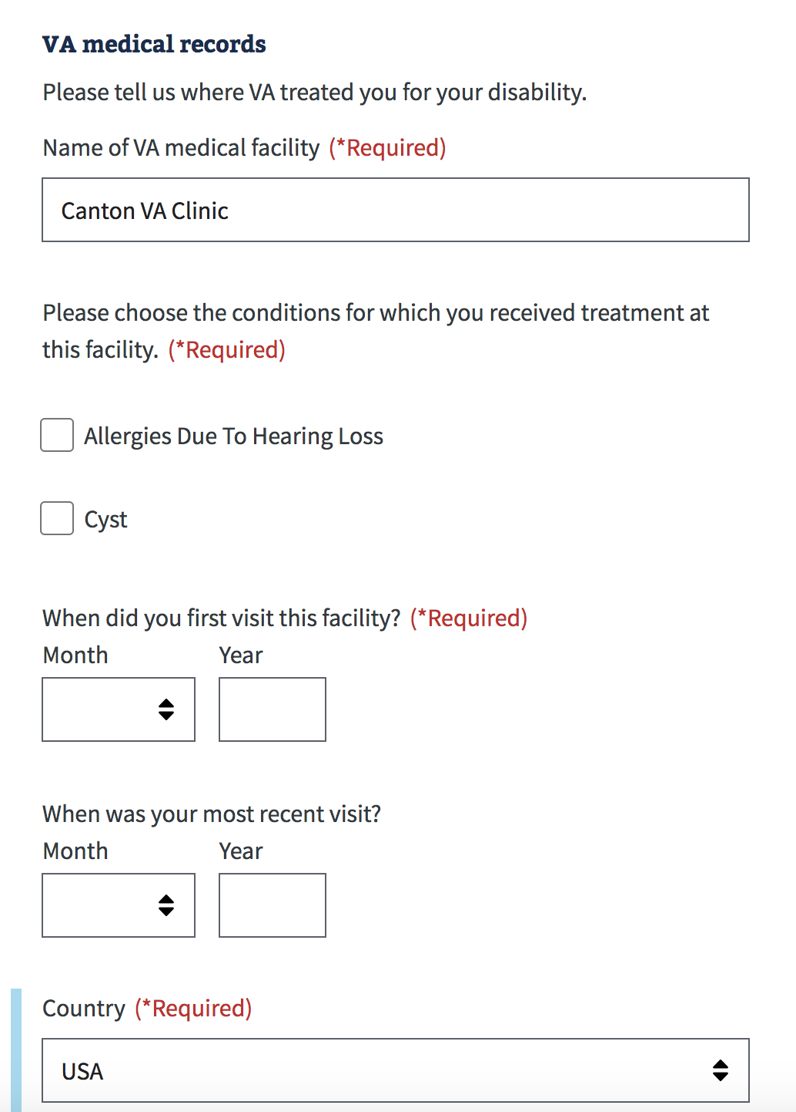

**Private Medical Records**

**Upload**

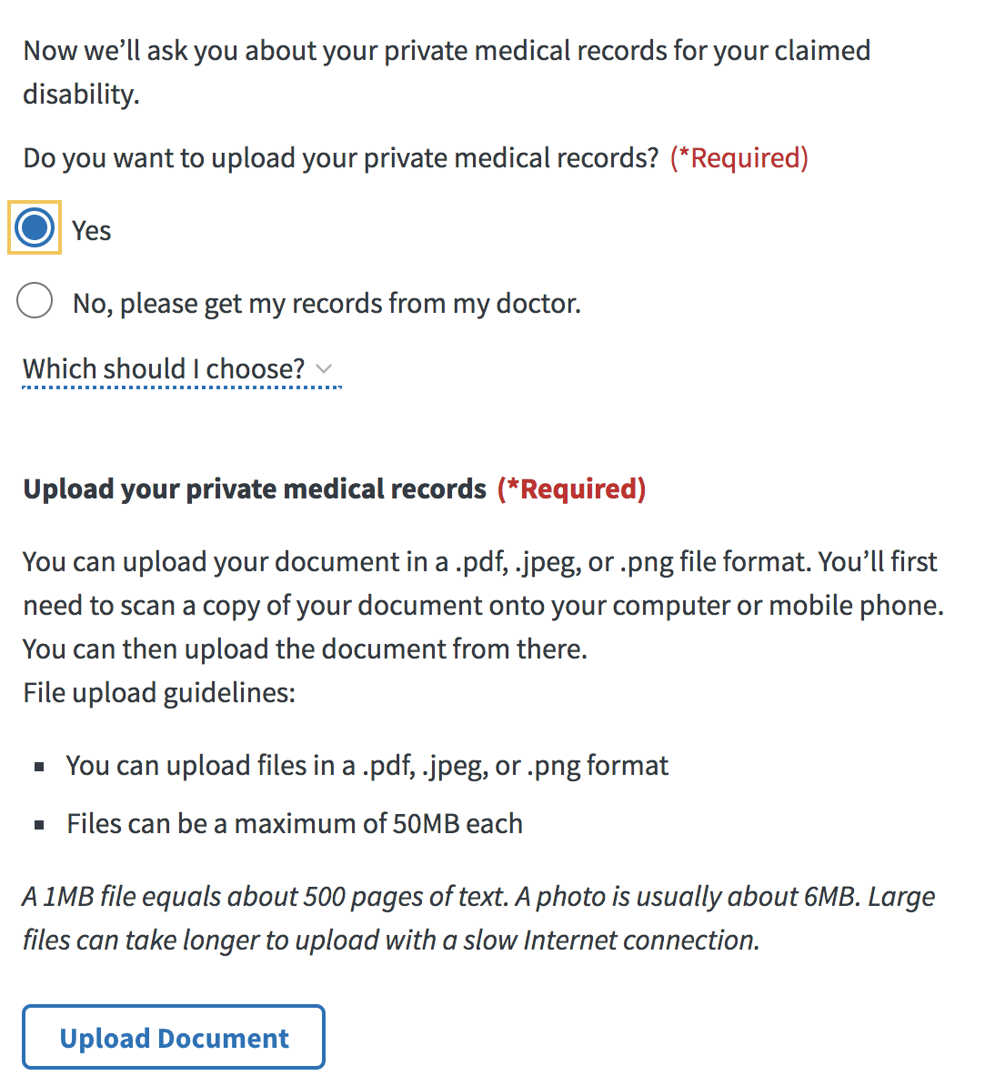

**Complete 4142/4142a**

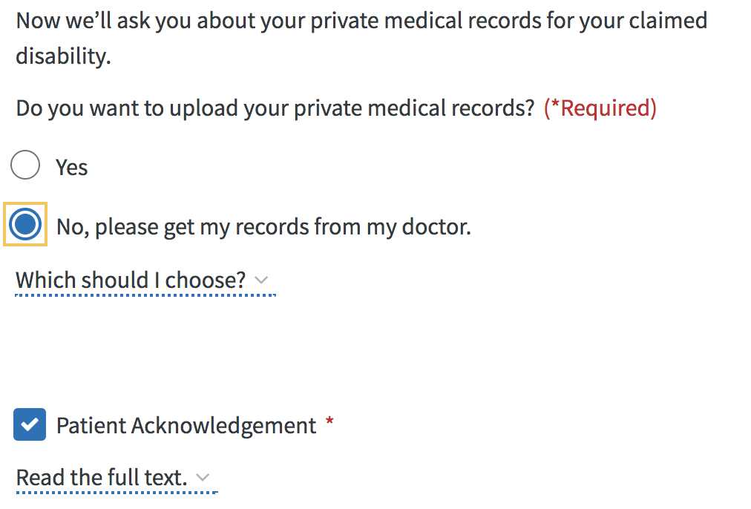

**4142a Cont’d**

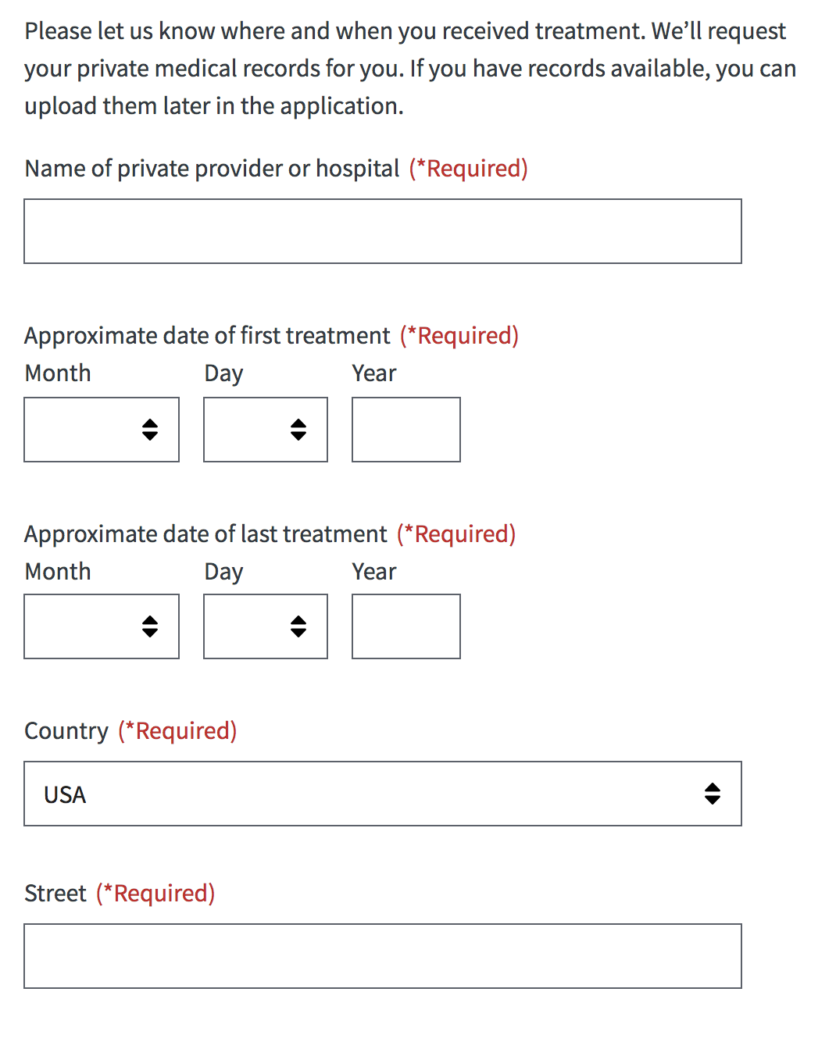

**Exam Info**

On the Exam screen, Veterans can find answers to common questions about a claim exam in the dropdown by selecting the ‘+’ icon.

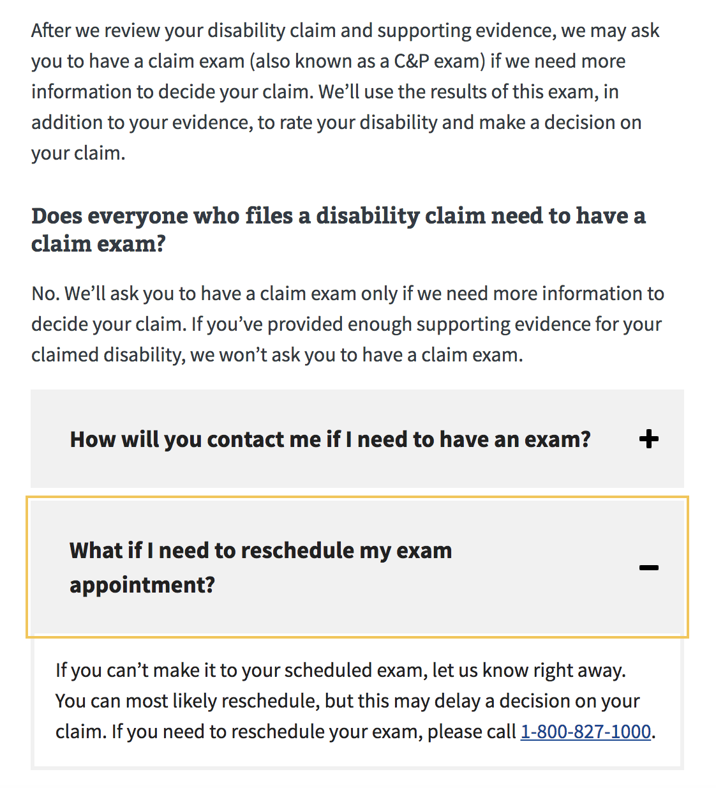

**Part 4: Veteran Details**

Veterans’ contact information is pulled from the Veteran’s profile. . Any edits or updates made here will apply only to the 526EZ application.

To update permanent address and email, the Veteran needs to edit this information on their profile page.

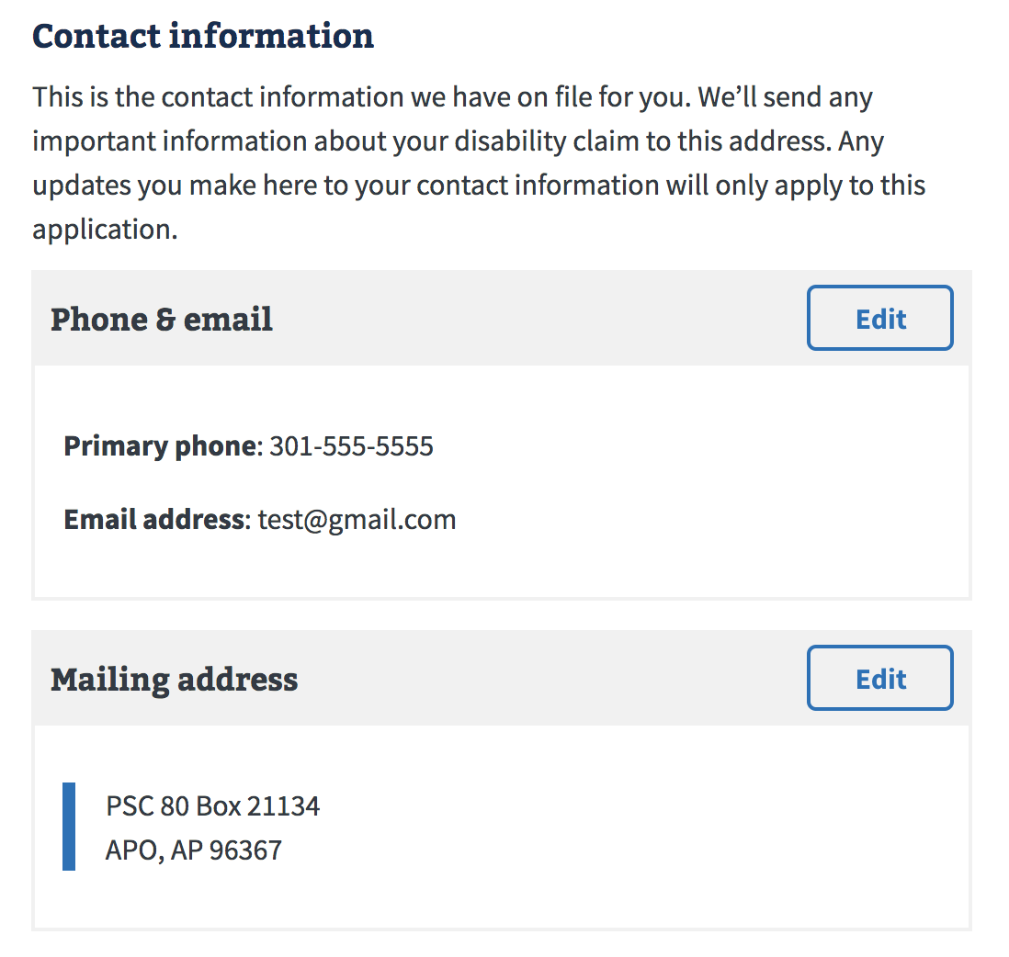

**Payment Info**

Veteran payment information is pre-populated if it exists in the Veteran’s record.This information can be edited for the 526 application.

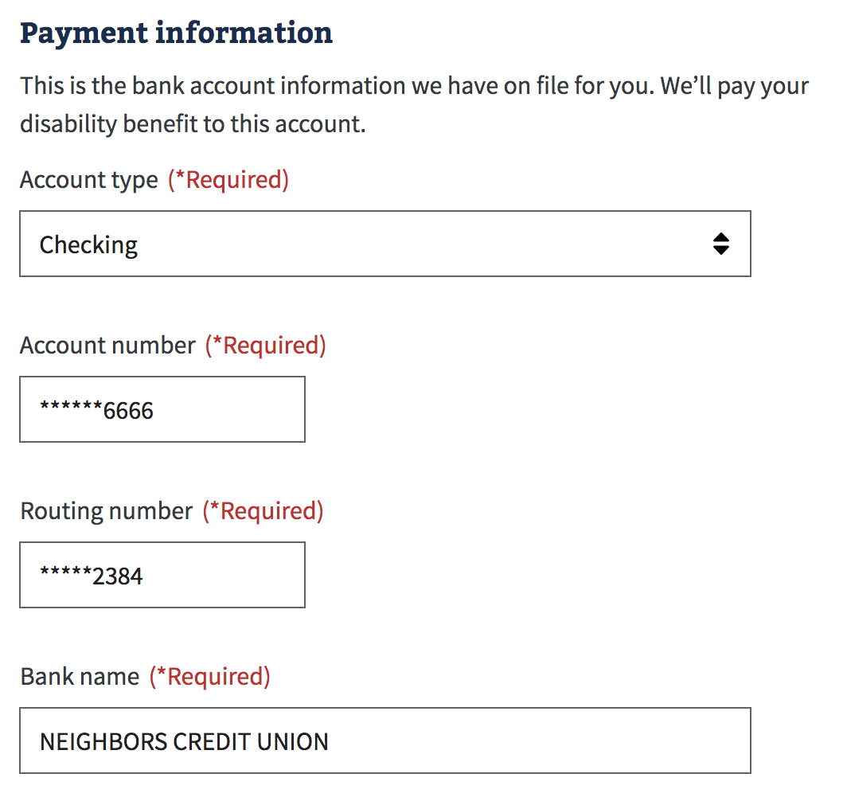

**Homelessness**

On this screen, Veterans let us know whether or not they are homeless. If they answer “Yes”, we ask the Veteran to provide additional information. If “No”, the Veteran continues to the next screen. .

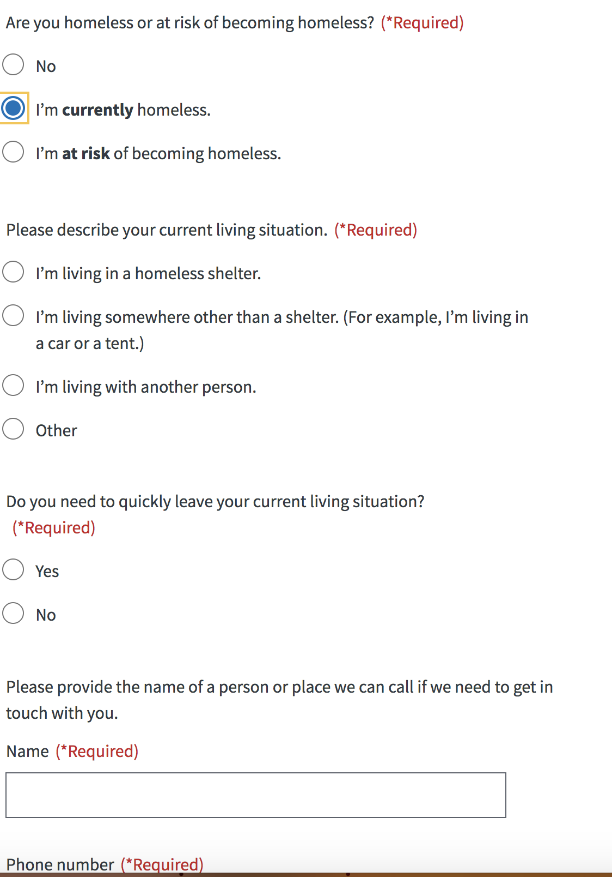

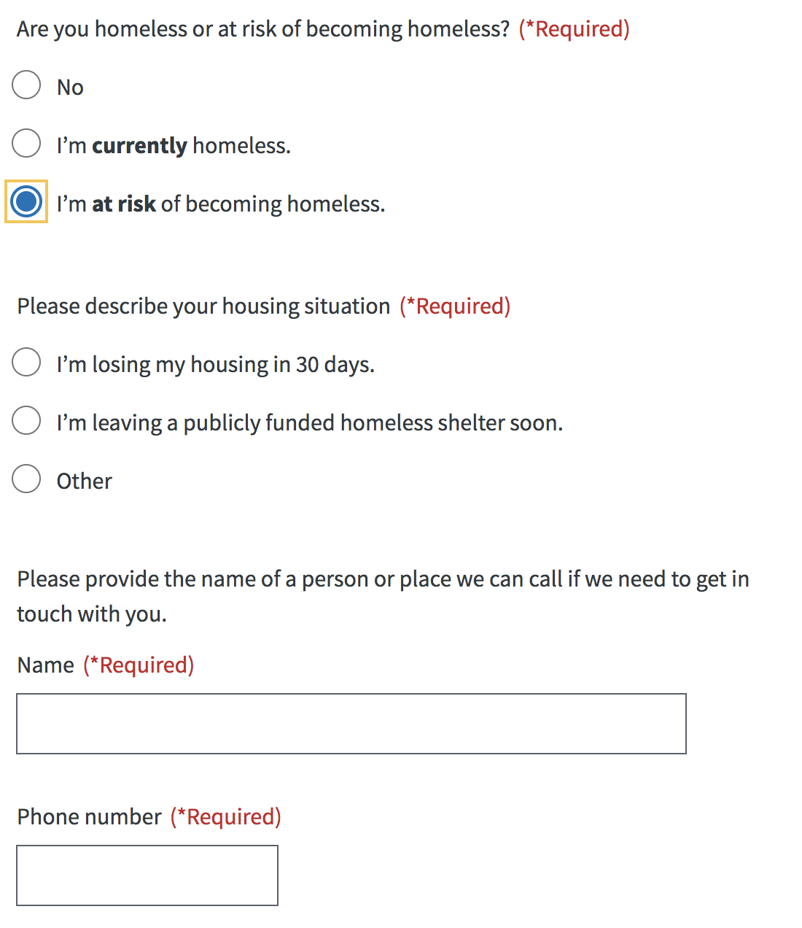

**VA Employee**

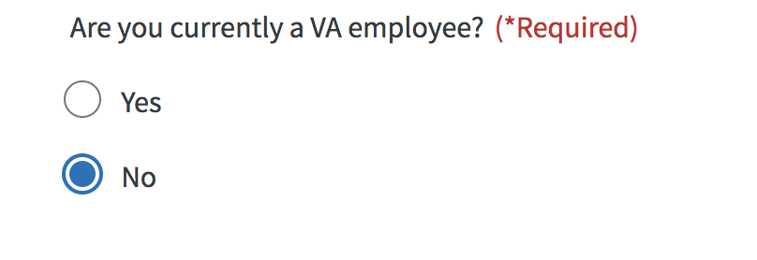

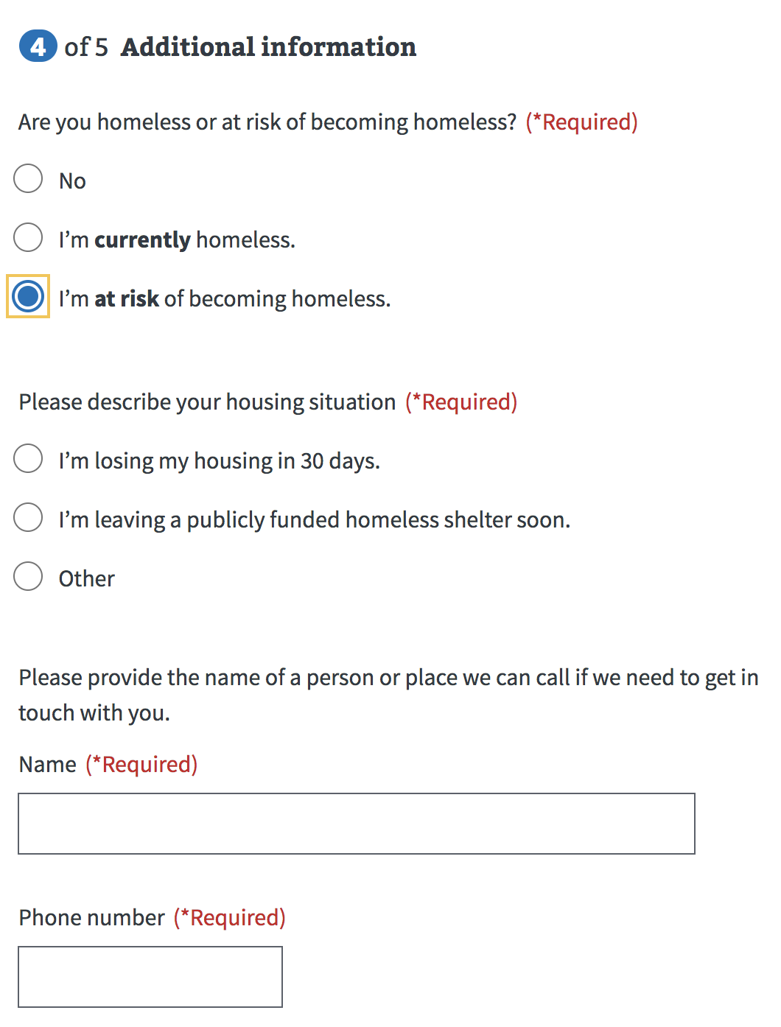

**Retirement Pay Waiver**

If a Veteran indicates earlier in the application that they receive retirement pay, we show the following waiver screen.

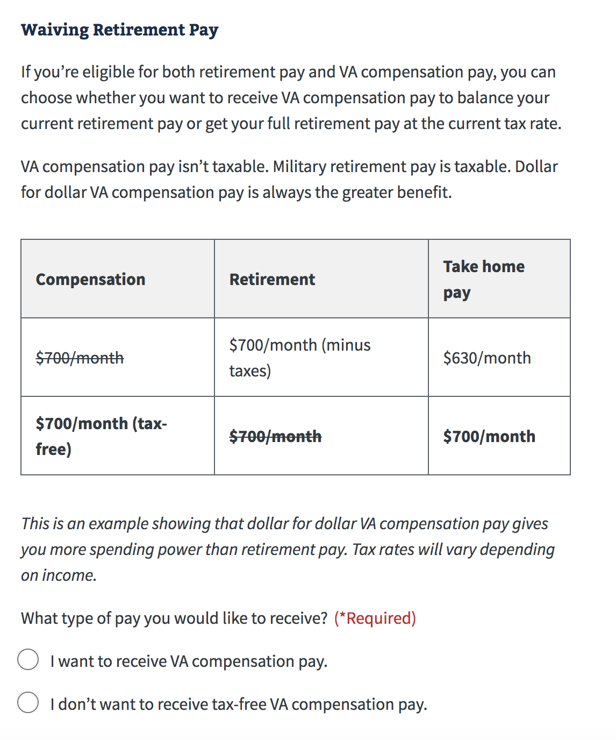

**Training Pay Waiver**

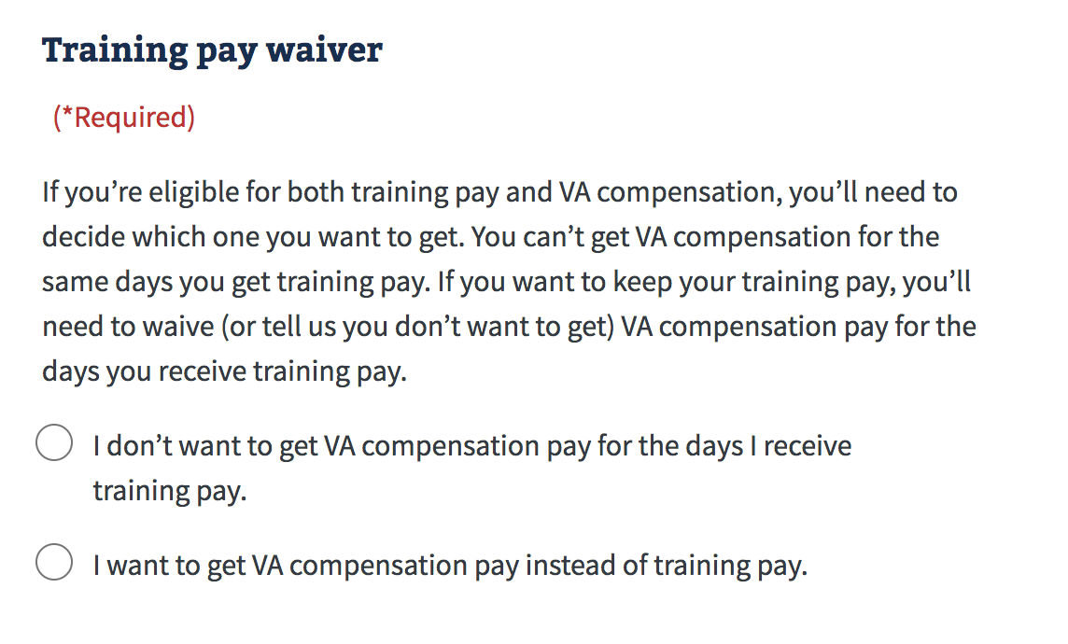

**Fully Developed Claim**

We’ll ask Veterans if they have provided all their supporting evidence and if they want to participate in the Fully Developed Claim (FDC) program. If they have additional information to submit with their tapplication, then we’ll review their claim through the standard claim process. . More information about the FDC program is provided in a link on this screen.

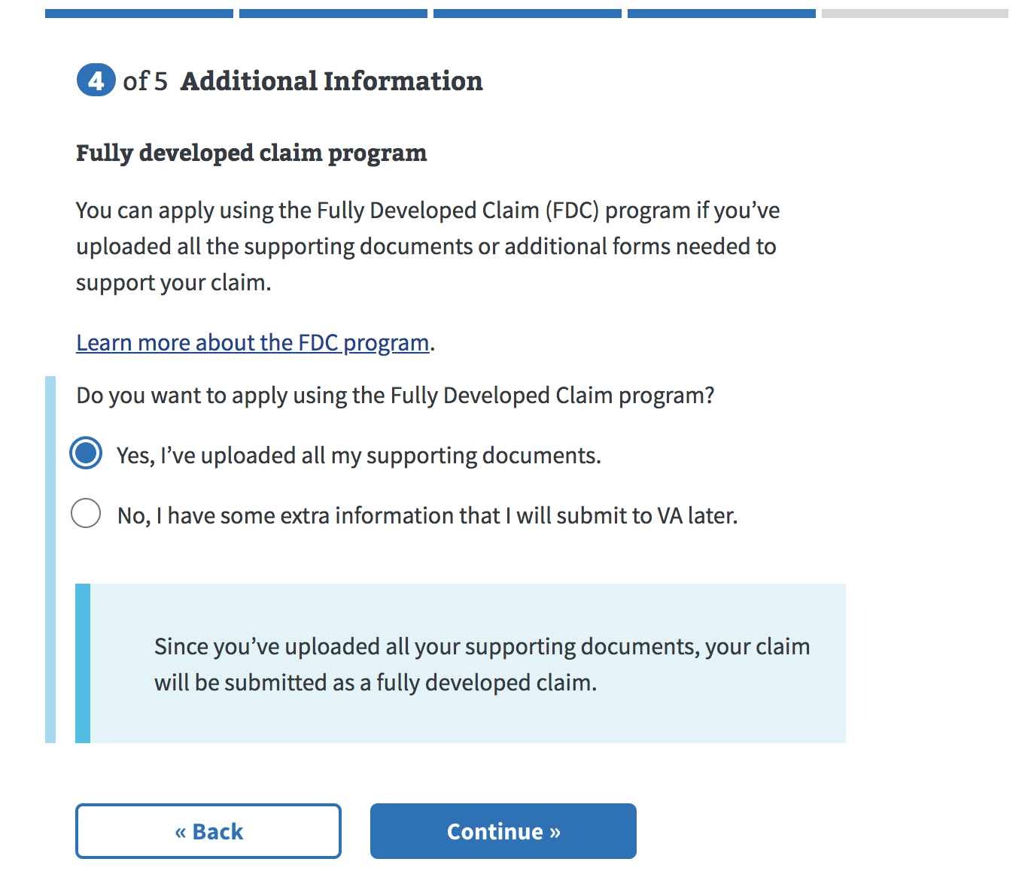

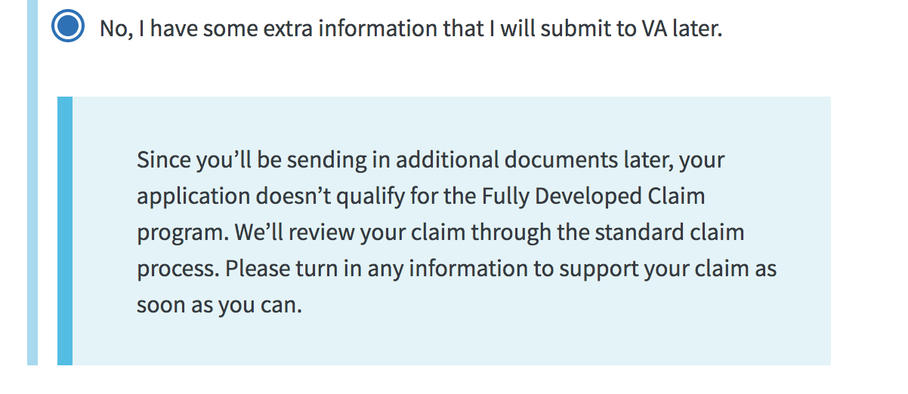

## **Part 5: Review Application**

## Before submitting their application, Veterans can review each section of the form for accuracy, using the ‘+’ toggle buttons to reveal detailed information. In order to submit the application, acceptance of the privacy is required by clicking the provided checkbox.

## 

## 

Successful Submission: Submitted applications will receive a confirmation message that contains a **‘Claim ID’** number that Veterans can use to track their application. A Veteran should be able to review the status of their claim using the Claim Status tool within 24 hours of submitting.

## 

After Submit: A claim is electronically created for the Veteran in the VBMS database for VBA. In addition, a pdf version of the 21-526-EZ form is created and sentto the National Work Queue to be reviewed. .

Success Confirmation

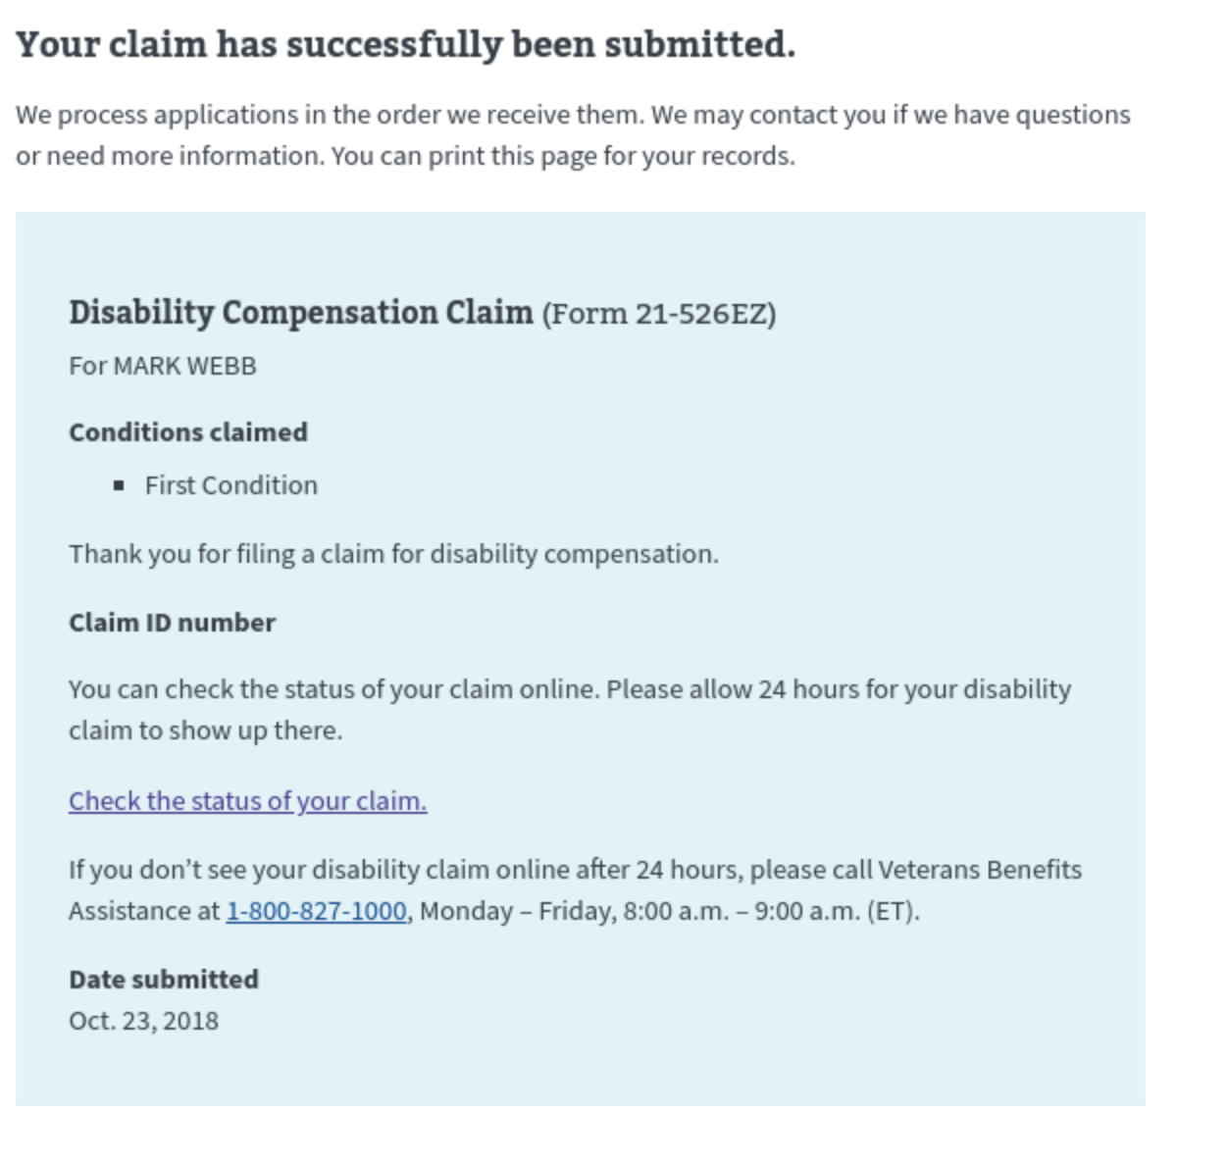

Check back later Confirmation message

Veterans will see this message when there is a backup of submissions in the queue. The system will retry submitting the application until successful within a 24-hour period.

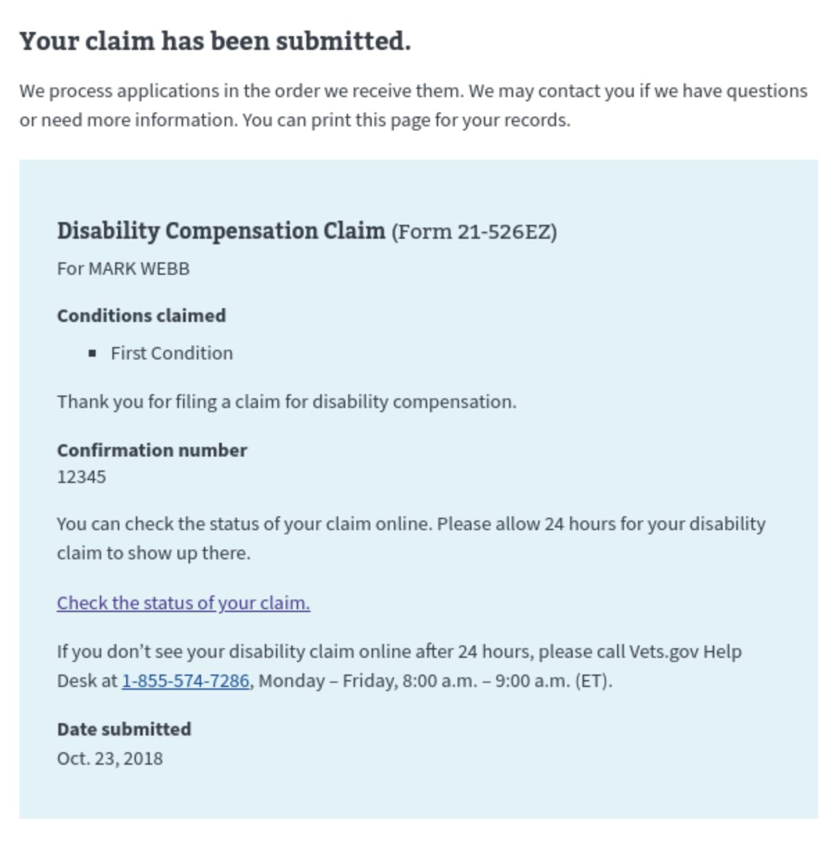

Error confirmation

A Veteran might see this an error submission message when there is a partner service outage, site maintenance or downtime, or problem with the data quality.

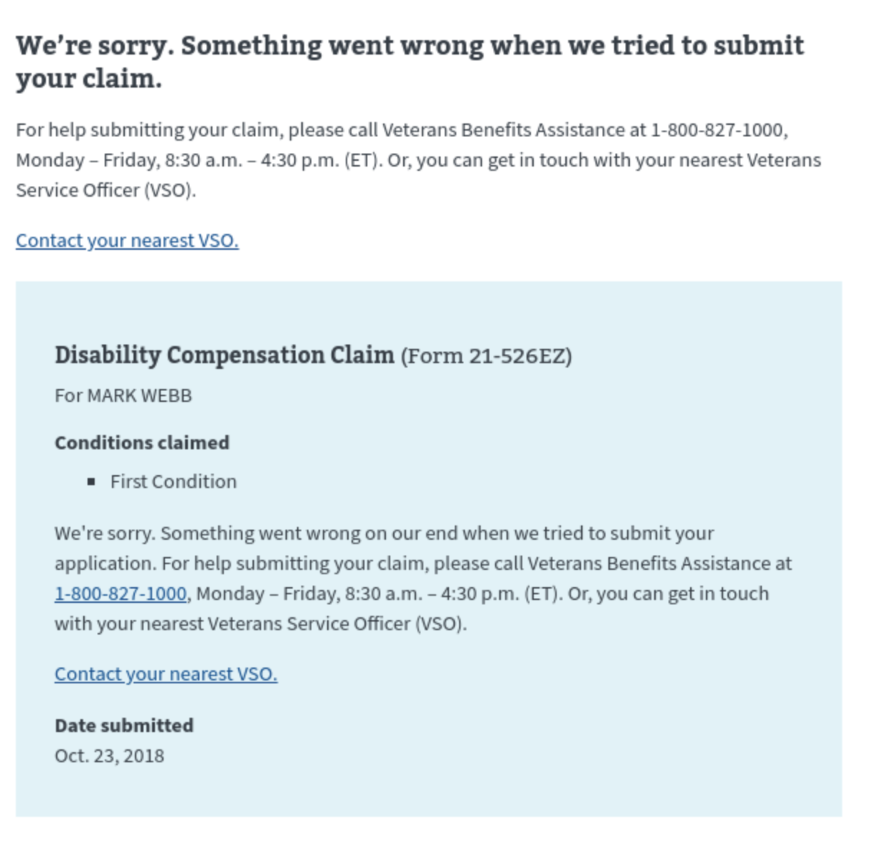

# Error & Notification Log

**Error for Unverified (missing SSN, EDIPI, and/or Corporate DB ID)**

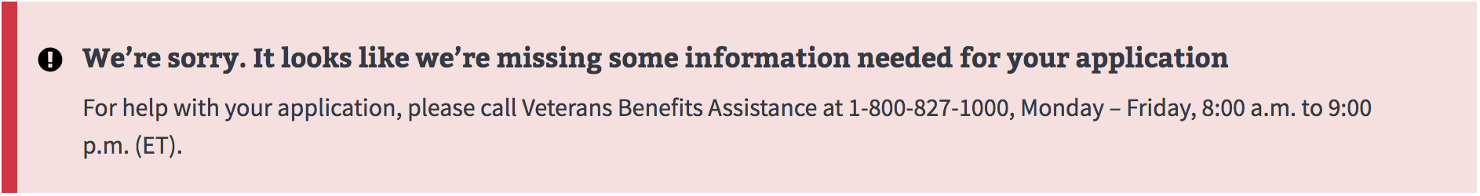

Will look like this on Dashboard:

*Please note this message will be updated to reflect VA.gov, not vets.gov

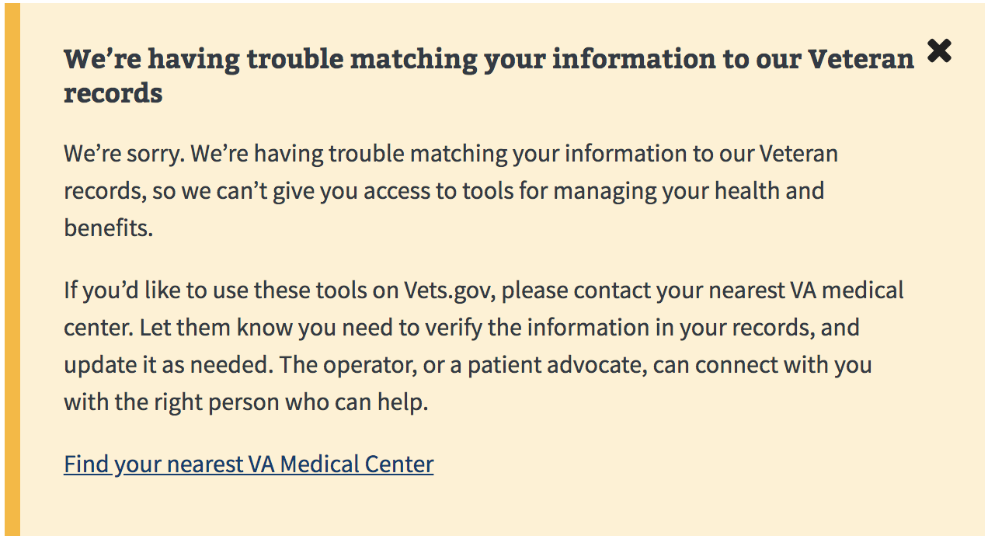

**ITF**

## ITF (description) - selecting the blue ‘Start’ button (below) will trigger the creation of an ITF (Intent to File) date for the veteran.

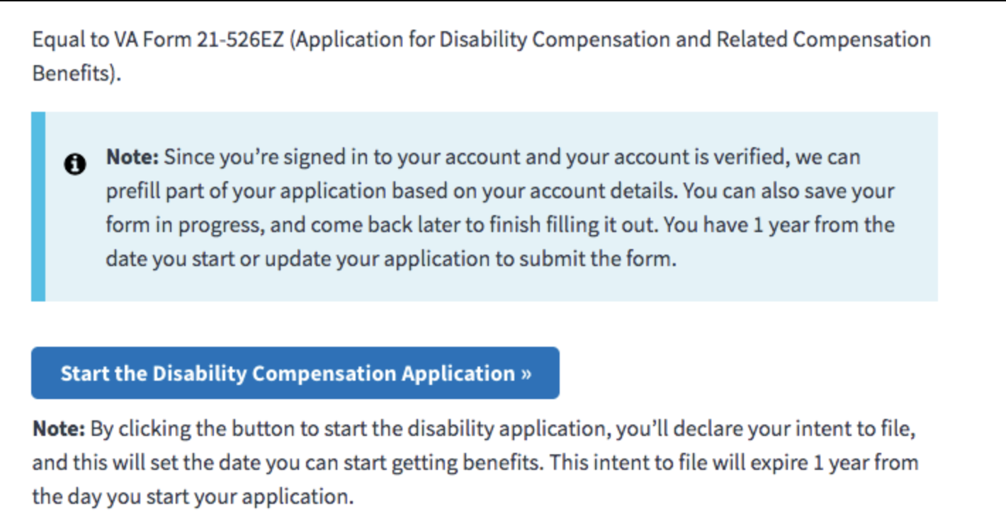

ITF (created)

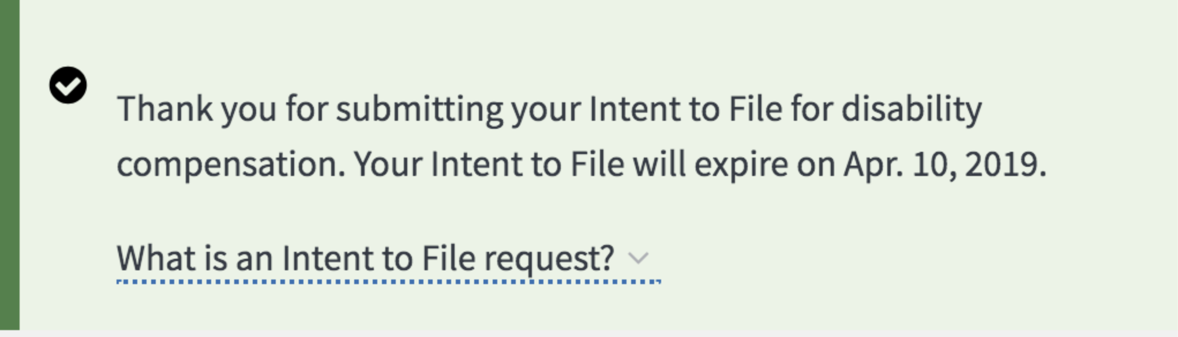

ITF (retrieved) - this message appears if a veteran already as an ITF date on record.

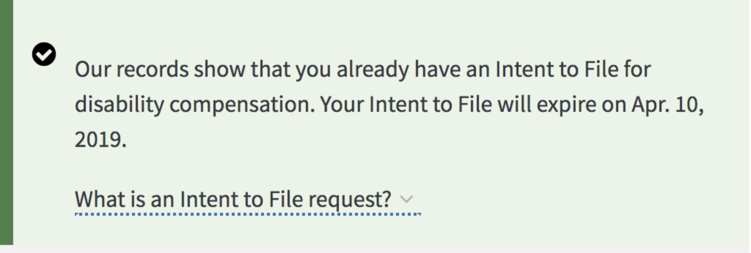

ITF (renewed)

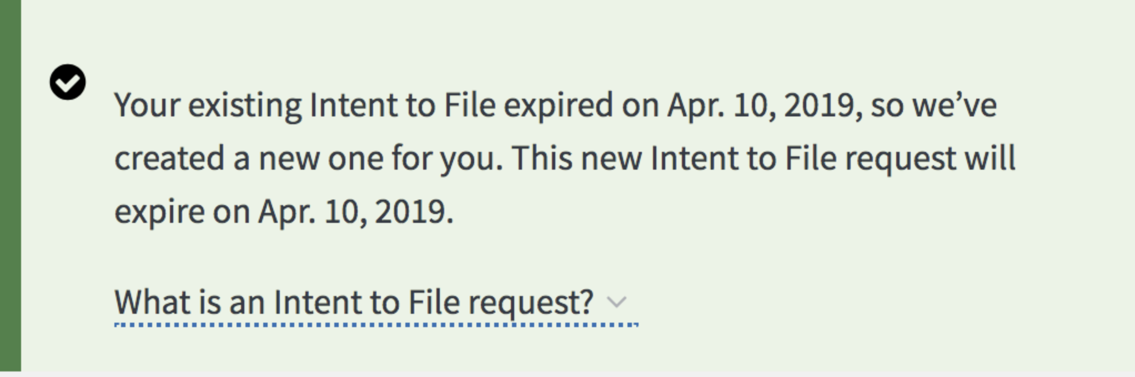

ITF (error: not retrieved for returning user)

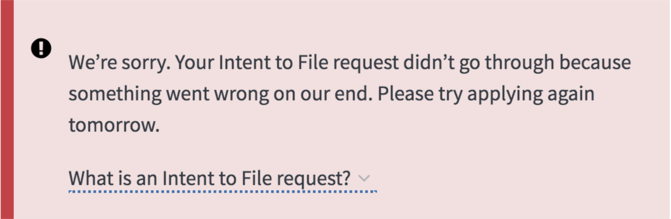

ITF (error: not retrieved for new user)

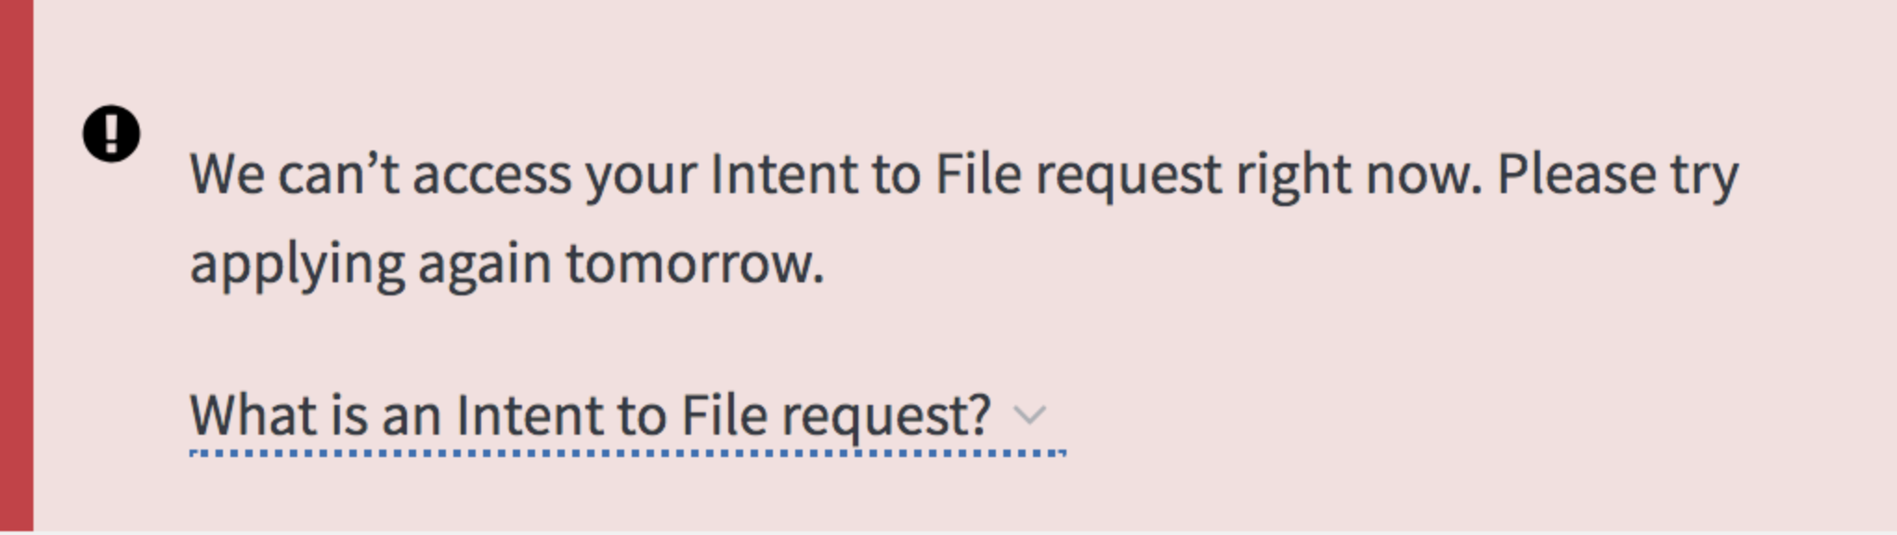

ITF (error: not created)

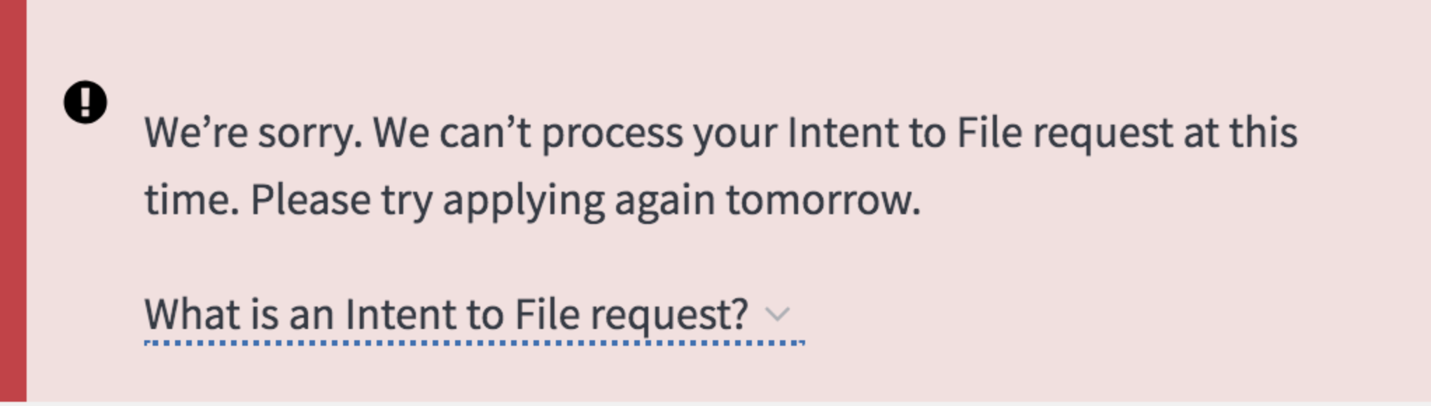

ITF (error: not renewed)

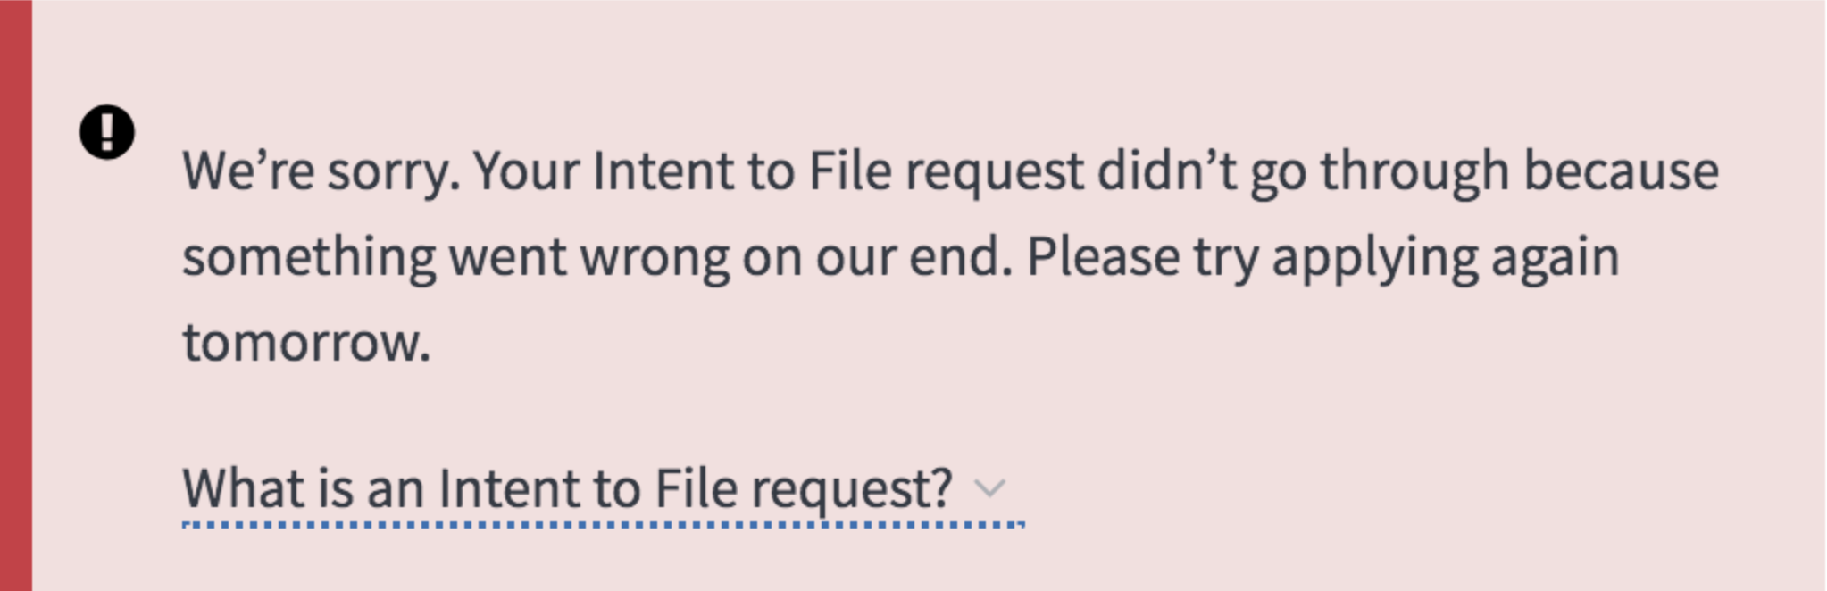

The following table contains the message types and notifications that would appear for standard errors and failures. Some messages may vary slightly as we develop updates versions of the tool.

**Save in Progress**

|  |  |  |  |
| --- | --- | --- | --- |
| **Scenario** | **Title** | **Description** | **Location** |
| Save in progress data |  | Application has been saved. Last saved on m/dd/yyy at HH:MMam/pm | Below affected component |
| Unable to complete an automated task (e.g. save application in progress) | We couldn't save your form | We're sorry. Something went wrong when we tried to save your form. If you're on a secure and private computer, you can leave this page open and try saving your form again in a few minutes. If you're on a public computer, you can continue to fill out your form, but it won't automatically save as you fill it out. | Below affected component |

## 

.

### **System downtime**

Variations in messaging will be contingent on:

* Whether or not the downtime is scheduled/expected
* If scheduled, when the application will be back up (precise time stamp if known, general estimate if not)
* If not expected, general estimate of when the application will be back up

|  |  |  |  |
| --- | --- | --- | --- |
| **Scenario** | **Title** | **Description** | **Location** |
| Entire site is not accessible (scheduled downtime) | Vets.gov is down for maintenance right now | We're sorry. VA.gov isn't ready for you right now. We're doing some work to help make this site even better for Veterans, Servicemembers, and family members like you. We hope to finish our work by [DATE/TIME]. Please check back then. | Replace page |
| Entire site is not accessible (expected) | Vets.gov isn't working right now | We're sorry. Something went wrong on our end. Please refresh this page or try again [LENGTH OF TIME (ie, "tomorrow" or "in an hour")]. | Replace page |
| Entire site is accessible | We're working on the site | We’re doing some work on VA.gov right now. You should still be able to use the applications and tools. But if you have any trouble, please check back soon. | Banner |
| Application or page is not accessible | [APPLICATION NAME] is down for maintenance | We're making some updates to [APPLICATION NAME]. We're sorry it's not working right now, and we hope to be finished by [DATE], [TIME]. Please check back soon. | Replace page below title |
| Application or page is not accessible, no timeframe | [APPLICATION NAME] is down for maintenance | We're making some updates to [APPLICATION NAME]. We're sorry it's not working right now. Please check back soon. | Replace page below title |
| Application or page is accessible (general message; specific iterations to be added later) | Some parts of this may not be working | You can still use [APPLICATION/PAGE NAME], but some parts of it may not work for you. If you're having trouble, please try again later. | Below page title |
| Component is not accessible (general message; specific iterations to be added later) | [COMPONENT NAME] isn't working right now | We're sorry. Something went wrong on our end. Please refresh this page or try again [LENGTH OF TIME (ie, "tomorrow" or "in an hour")]. | Replace affected component |
| Component is accessible (general message; [see application/component specific messages](https://github.com/department-of-veterans-affairs/vets.gov-team/blob/master/Products/Design%20System/Guidelines/Error%20handling/Dictionary/Access%20Messaging.md)) | Some information may not be up to date | We're sorry. Something's not working quite right. You can still use [COMPONENT NAME], but you may not be able to see all your updated information. If you're having trouble, please try again [LENGTH OF TIME (ie, "tomorrow" or "in an hour")]. | Above affected component |
| Unable to complete a user-initiated task, can't proceed | We've run into a problem | We're sorry. Something went wrong on our end. Please try again. | Above page title |
| Unable to complete a user-initiated task, can still proceed | We've run into a problem | We're sorry. Something went wrong on our end. You can try again now, or move on to the next step and come back later to complete this. | Above page title |

### 

### **Network connection loss**

|  |  |  |  |
| --- | --- | --- | --- |
| **Scenario** | **Title** | **Description** | **Location** |
| Application/page/component is not accessible due to user connection loss | We can't load [APPLICATION/PAGE/COMPONENT NAME] | Please make sure you're connected to the Internet, and refresh this page to try again. | Below page title |
| Unable to complete an automated task (e.g. save application in progress) due to user connection loss | We can't save your form right now | Please make sure you're connected to the Internet, and then try saving your form again. | Below affected component |
| Unable to complete a user-initiated task due to user connection loss | We've run into a problem | Please check to make sure you're connected to the Internet, and try again. | Above page title |

### 

### **Authorization**

|  |  |  |  |
| --- | --- | --- | --- |
| **Scenario** | **Title** | **Description** | **Location** |
| (Application) user's records are not found | We don't seem to have your records | We're sorry. We can't find your records in our system. If you think they should be here, please try again later or please call VA Benefits and Services at 1-800-827-1000.  If you have hearing loss, call TTY: 711.. | Replace content below page title |
| (Page) user's records are not found | We don't seem to have your records | We're sorry. We can't find your records in our system. If you think they should be here, please try again later or call please call VA Benefits and Services at 1-800-827-1000.  If you have hearing loss, call TTY: 711.t | Replace content below page title |
| (Component) user's records are not found | We don't seem to have your records | We're sorry. We can't find your records in our system. If you think they should be here, please try again later or lplease call VA Benefits and Services at 1-800-827-1000.  If you have hearing loss, call TTY: 711. | Replace affected component |
| (Application) user is not eligible for a benefit because they aren't a Veteran/dependent/spouse | You're not eligible for this benefit | It looks like you're not eligible for this benefit based on the information you've given us. Please check your eligibility again. | - |

### 

### **Empty state**

|  |  |  |  |
| --- | --- | --- | --- |
| **Scenario** | **Title** | **Description** | **Location** |
| (Application) No data tied to the user or scenario | No [DATA TYPE (ie, prescription refills or health records)] to show | We don't have any [DATA TYPE] in our system to show here. | Replace content below page title |
| (Page) no data tied to the user or scenario | No [DATA TYPE] to show | We don't have any [DATA TYPE] in our system to show here. | Replace content below page title |
| (Component) no data tied to the user or scenario | No [DATA TYPE] to show | We don't have any [DATA TYPE] for you in our system. | Replace affected component |

## 

## **Feedback messaging**

The application’s response when the user is interacting with it. The majority of create, read, update, delete (CRUD) actions will result in feedback messaging.

*Note: See* [*content style guide*](https://github.com/department-of-veterans-affairs/vets.gov-team/blob/master/Products/Design%20System/Guidelines/Error%20handling/Content%20Style%20Guide.md#next-step-calls-to-action) *for guidance on when to consider adding instruction to call the Vets.gov Help Desk or other "next-step" call to action.*

**Form Restart**

When a user wishes to restart the 526 form (i.e., hit 'start over' on the intro page), they see an error that 'something went wrong' after the form loads. If they go back to the intro page, they see the 'start disability compensation application' button, and clicking on it results in the form working as usual. So, the form must be restarted twice.

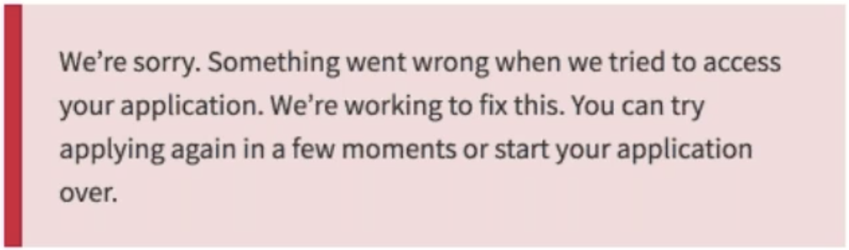

Mitigation steps:

Go back to root url ([vets.gov/https://www.vets.gov/disability-benefits/apply/form-526-disability-claim/](http://vets.gov/https://www.vets.gov/disability-benefits/apply/form-526-disability-claim/)) and try again, at least twice

*Please note: message will be updated to reflect vets.gov, not VA.gov

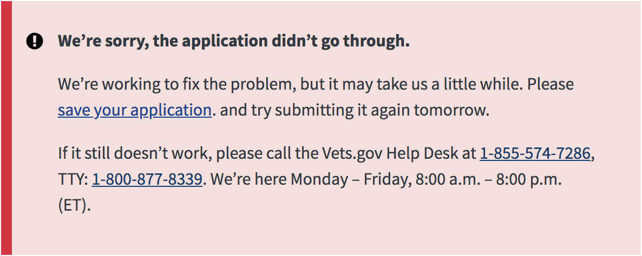

Recommended Actions if a veteran calls saying they have received an error:

1. Verify the source: vets.gov, eBenefits, SEP (only if working with VSO)
2. If VA.gov make sure that the Veteran can see their identity (SSN, DOB, Gender, etc), address, contact info, payment info, service history when they log into the application. If payment info is not on file or other records are missing, this could produce an error.
3. If you have access to VBMS, check recently submitted claims. If there is nothing there for the veteran, double-check to see if the veteran has any confirmation number for their submission. If not, batch those reports for vets.gov. We’ll be logging failed applications and retrying them. Anything that we’re unable to push through will be manually sent over for forced entry. The cadence of this will have to be determined by volume.